Measurement Write-Up (Plan 4)

EMSE 6577

Drew Gobbi, Olivia Wang, Olatunji Akinbule, Maddie Warndorf

**1. Revisit your research question. Restate the question as a hypothesis, and list the key constructs and any proposed relationship (causal or otherwise) between them.**

General Hypothesis: a certain combination of factors contribute to higher opioid use.

Hypothesis: People in the selected areas who have low incomes and who are middle aged are more prone to higher opioid use.

Key Constructs Related to the Hypothesis: opioid use, people with low income, people who are middle aged.

* Opioid usage - because we cannot directly measure each person’s opioid usage, especially if they don’t report or go to the hospital, you have no way to know if someone uses opioids or not, if they do, how much.
* Low income - because we can not directly measure what exactly is considered “low” for income, and it might be subjective because everyone’s opinion about what low income should be could vary.
* Middle age - because we don’t exactly know what exactly is considered middle age especially when it could vary from region to region, from some demographics to other demographics and etc.

Proposed Relationship: We propose that the constructs of people with low income and people who are middle aged are both correlational to the construct of opioid use.

**2. Revisit your pilot data. List all of the features in your pilot data. Create a table relating your features to your constructs. Explicitly highlight those constructs for which you don’t have features, and those features that don’t correspond to constructs in your question.**

Wastewater Pilot Data: Site Code (TP02, TP04, TP05), Chemical Name, Sample_Date, Population Normalized Mass Load (PNML) (mg/day/1000 capita), Geometry (Geographic Polygon)

Opioid EMS Call Pilot Data: Call Date, Geometry (Geographic Point), Number of Opioid Related EMS Calls

|  |  |
| --- | --- |
| Construct | Feature |
| Opioid Usage | Population Normalized Mass Load (PNML) (mg/day/1000 capita)  Number of Opioid Related EMS Calls |
| Low Income |  |
| Middle Age |  |
|  | Sample_Date  Call Date |
|  | Site Code (TP02, TP04, TP05)  Geometry (Geographic Polygon)  Geometry (Geographic Point) |
|  | Chemical Name |

**3. For each construct missing a feature, come up with a plan to measure that construct (or otherwise develop a scale to measure that construct).**

We have three constructs. We decided to use two features to measure opioid use, one is Wastewater opioid concentration data and the other is EMS Call Center Opioid report data. However, we don’t currently have features to measure the construct of low income and the construct of middle age, and we think we will use poverty level as a measure/feature of low income and if a household’s income is below poverty level, we think this household is an low-income household. However, for each area as a whole (because we cannot study opioids use at individual level), we are going to use the percentage of households whose incomes are below the federal poverty level as the percentage of low income households in our analysis. We are also going to use the upper bound of the lowest 10% of all household incomes in Tempe as another measure for the construct of low income. If a household’s income is within the lowest 10% range of all incomes in tempe,then it is considered a low-income household under this measure. However, for each area as a whole, we are going to use the percentage of households whose incomes are within the lowest 10% range of all household incomes in Tempe as the percentage of low income households in our analysis. We are going to use age range of 45-65 as a measure/feature of middle age, and if a specific individual’s age is within this age range, we consider this person to be middle-aged individual. However, for each area as a whole, we are going to use the percentage of individuals whose ages are within the range of 45-65 as the percentage of middle-aged population in our analysis.

**4. For each feature, indicate whether it is nominal, ordinal, interval, or ratio. Use your constructs to justify these selections.**

Based on the construct of opioid usage, we want the features PNML and Number of Opioid Related EMS Calls to be ratio because they both have an absolute zero.

And for the features we want to extract from census data:

* We want the percentage of the population whose incomes are below the federal poverty level to be a ratio because the percentage of the population whose incomes are below the federal poverty level does have an absolute zero.
* We want the percentage of the population whose age is within middle age range to be ratio also because the percentage of the population whose age is within middle age range does have an absolute zero.

For the features that are not associated to a construct:

* We are using the features Site code, Geometry (Geographic Polygon), and Geometry (Geographic Point) as geographical data boundaries, therefore we are declaring them as nominal.
* We are not focused on a specific type of opioid so we did not create a construct for it. Therefore, for the sake of our project we want the feature Chemical name to be nominal.
* Since we are assuming that time is independant, we do not have a construct based on time. Therefore, to help control the time variance we are declaring the features Sample_date and Call Date as nominal[1].

**5. Use your pilot data to demonstrate as much validity of each feature/construct pair as you can. For each feature/construct pair, justify why this is a valid mapping. Specifically indicate whether it has face validity, content validity, predictive validity, and/or convergent-discriminant validity.**

The PNML estimates of opioid use are a face valid measure. It makes sense that these chemical compounds should be detectable in wastewater byproducts. The PNML estimates could also be considered content valid if considering some other subjective criteria. For example, the PNML measurement is almost impossible for individuals to fake, and represents an anonymized view of the average drug use in a concentration. This means it is likely to be unbiased.

Our alternative measure, EMS calls, are also valid. It makes sense that one way to detect Opioid usage would be from overdoses reported by health care professionals. Content validity may be harder to establish in this case but could also be possible. EMS data is collected by healthcare professionals as they respond to calls for help, and provides a baseline for detection. However, determination about opioid use could be hard to measure in an emergency situation, and also represents a detection problem. Only those who actually call EMS are counted towards the total estimate of opioid use.

Because of these factors, we think that the PNML wastewater estimate may be a better, unbiased measure of the opioid use construct. To test this, we examine the convergent-discriminant validity of the two features below.

**6. For each feature/construct pair, test its convergent-discriminant validity using the data that you have available. If you can’t do so using your available data, develop a plan to gather data to do so, and indicate the resources that would be required to implement this plan. If you can, implement this plan. If you can’t, justify your continued use of this feature.**

We tested the convergent-discriminant relationship between the PNML and the EMS calls in our pilot data by comparing the measure, correlation, and trend of each variable to one another to look for consistency. First, we restricted our analysis to only calls where opioid was detected in 2018 and within our site collection areas. Because of the low number of EMS calls in areas 4 and 5 in our pilot data, we focused only on area 2 for this preliminary analysis. A map showing the EMS calls in our collection areas is shown below. Collection area 2 is highlighted in red.

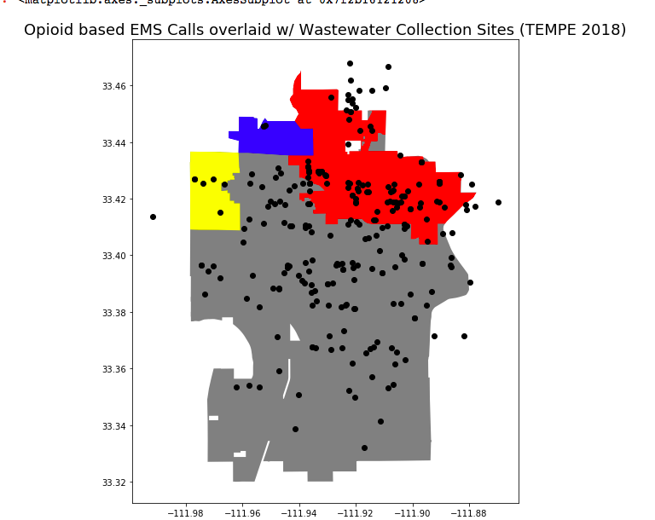

Then, we compared the level of EMS estimated opioid use to the PNML estimated opioid use in area 2 each month. The count of opioid related EMS calls in a given month represents that feature’s ability to measure the level of drug use. Because PNML represents a concentration of drug use per 1000 and is measured daily, we used the monthly average as our measure of detected opioid use.

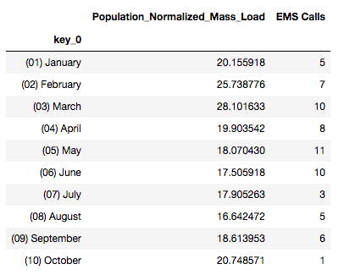

Examining the relationship between the two measures of opioid use shows that they are somewhat divergent. They are only lightly correlated as shown in the chart below, and only loosely follow the same trend over time. This suggests that the ways in which they detect opioid use are different. Because we think that there is bias in the EMS detection of opioid use, this gives a foundation to test our hypothesis.

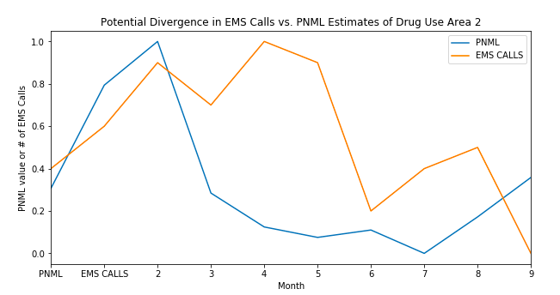

**Correlation of PNML vs EMS Calls**

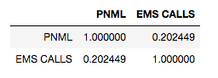

**7. For each feature, justify why this is a reliable measure by quantifying measurement error. If you cannot do so, come up with a plan to collect data to do so.**

For the PNML data, the researchers include a quantitative measure of the detected measurement error of each sample they collect. We assume that this a reliable measure collected by experts in their field that shows the relative margin of error of each load in the waste water. At this point in time, we are currently evaluating how to translate this chemical deviation into a statistical one, such as a standard error or confidence interval.

The measurement error of the EMS call data is not easily quantifiable because it is only reported by the emergency responders. A potential way to measure error in this case could be to compare the number of opioid related EMS calls to the number of reported overdoses within a collection area and calculate a mean squared error. However, this could be hard to implement because of the likely divergence between these two measures. Some individuals may overdose in hospitals without ever having contacted EMS.

For all demographic features extracted from the census, we can leverage the sampling weights and collection methods of the ACS that are published by the Census Bureau to get an estimated variance for each measure. This is likely a worst case scenario as well, as the census publishes the estimated margin of error for these estimates for a large number of features.

**8. For each feature, indicate any potential sources of methodological bias. Come up with (and if possible, implement) a plan to mitigate this bias.**

Features in Wastewater Concentration pilot data: Site code (TP02, TP04, TP05), Chemical name, Sample_date, Population Normalized Mass Load (PNML) (mg/day/1000 capita), Geometry (Geographic Polygon)

Features in EMS Calls pilot data: Geometry (Geographic Point), Call Date, Number of Opioid Related EMS Calls

Sources of methodological bias:

* *Number of Opioid Related EMS Calls*: This will be dependent on the report provided by the caller. It is possible that a caller misses the indicators of a drug usage on an EMS call.
* *Call Date, Sample_Date:* We expect time dependent trends to be existent in our data and can address this issue by aggregating our data points up to monthly measures or lower our frequency samples. To ensure that there is no methodological bias, we tested to stationary at the monthly level.

Features that we have deemed to not have any potential sources of methodological bias:

* Geometry (Geographic Point), Geometry (Geographic Polygon), and Site Code: There is no methodological bias with geographical coordinates since we are using the same spatial reference system.
* Chemical name: To the best of our knowledge there is no methodological bias present with the chemical nomenclature of the opioids in focus.

**9. For each feature/construct pair, indicate the appropriate measures of reliability: Cronbach’s alpha, internal consistency, Fleiss’ Kappa, etc. All of these measures depend on multiple features per construct. If you don’t have this for some constructs, develop a plan to gather data to get the appropriate features, and indicate the resources that would be required to implement this plan. If you can implement this plan, do so.**

We think for construct of opioid use we’ll use internal consistency because both features/measurements for opioid use is ratio, which means that they are continuous variable, and we should use correlation for continuous variables. We will assign each area as the item and within each item we will look at the measurement of opioid use from PNML and EMS Call center Opioid report and see how they correlate.

For construct of middle age, there really is not another way of measuring age, so we think we don’t need to have multiple measures for construct of middle age.

For construct of low income, we’ll use internal consistency as well because both features/measures are ratio. Now we have the federal poverty level and we want to categorize households whose incomes are below the federal poverty level as low income households, however, we can also categorize low income household in another way, say, the household whose incomes are within the lowest 10 percentile of incomes in Tempe, AZ as low income households. In this case, we will assign each area as the item, and look at the percentage of the household whose incomes are below the federal poverty level and the percentage of the household whose incomes are within the lowest 10 percentile of all incomes in Tempe and see how they correlate

**10. For each existing *and proposed* feature and construct, list the threats to construct validity for your study and indicate any potential source of ethical concerns that may arise by collecting your data. What is your plan to fix these?**

The PNML is the primary indicator for opioid usage in each of the three sites and is subject to the mono-operation bias, even though we estimate that PNML will be a feasible estimate of opioid usage in our focus sites.

As a result we are incorporating the number of opioid related EMS calls from the EMS calls data to comparatively estimate the opioid usage in each of the three site codes in order to cater to potential mono-operation bias.

In addition opioid concentrations will fluctuate naturally from day to day depending on the amount of water and total mass of drugs input. We anticipate short term spikes or dips in PNML concentration - however our focus is on long term trends of interpreting our construct, opioid usage using the PNML.

Another major assumption is that there is a baseline level of prescribed drug usage for each of our focus sites that would count as noise. As such the PNML is aimed at primarily understanding unprescribed drug usage. In a scenario of a focus site where the prescribed drug usage accounts for the PNML we have a biased estimate of unprescribed drug users in our focus sites.

Ethical concerns:

The analysis is performed on community-aggregated and anonymized data points to understand drug use patterns. This allows for an anonymous analysis that can identify opportunities to improve treatment risk and factors. Consequently, we do not anticipate any ethical concerns with the study.

1. Source: https://statisticalanalysisconsulting.com/is-time-nominal-ordinal-interval-or-ratio-is-it-categorical-or-continuous/